Invextech Internship – Week 4 Task Report

Internship Details
Intern Name: Arquam Ali Shakeeb
Internship Domain: Full Stack Development & AI Automation
Company: Invextech
Week: 4
Submission Date: 22/7/2026

Week 4 Task Title
Task Name:
Talking to AI, and Building My First Automation

Assignment # 1

Fix bad prompts. You'll get three poorly written prompts. Rewrite each one clearly, and explain what was wrong with the original.
PROMPT#1
Tell me about AI.
Fixed prompt,
Explain Artificial Intelligence to a beginner in simple English. Include what AI is, how it works, three real-world examples, and the difference between AI and Machine Learning. Keep the explanation under 300 words.
PROMPT#2
Write an email.
Fixed prompt,
Write a professional email to a hiring manager thanking them for the interview. Express appreciation for their time, mention your enthusiasm for the role, and keep the email polite and under 150 words.
PROMPT#3
Help me with my code.
Fixed prompt,
I'm writing a JavaScript function to reverse a string, but it returns undefined. Here's my code:
function reverse(str) {
// code here
}
Please explain why it isn't working, identify the bug, and provide a corrected version with an explanation.

Assignment # 2

Test a system prompt. Write a system prompt that locks an AI into doing one specific job, like only qualifying leads. Try it on five different sample messages and write down what it says each time.
System Prompt,
You are a Lead Qualification AI. Your only job is to analyze customer messages and classify the lead. You must only return one word:
- Hot
- Warm
- Cold
Rules:
Hot: - Customer wants to buy now. Customer asks for pricing. Customer requests a demo. Customer has an urgent requirement.
Warm: - Customer is interested but needs more information. Customer is comparing options. Customer is asking questions.
Cold: - Customer is only exploring. Customer has no buying intention. Customer is not interested.
Test 1
Hi, I need pricing for your software. Can someone contact me today?
Answer
Hot
Test 2
I am interested in your product. Can you explain how it works?
Answer
Warm
Test 3
Just checking what services you offer. Not planning to buy right now.
Answer
Cold
Test 4
We need this solution for our company. Can we schedule a demo this week?
Answer
Hot
Test 5
What are the different plans available? I am comparing with other tools.
Answer
Warm

Assignment # 3
Build a working flow. A webhook receives a fake lead message, an AI step decides Hot, Warm, or Cold, and the result shows up somewhere you can see it, like Slack, a spreadsheet, or just the console.
Step 1:
Execute the Workflow on n8n.
It receives the lead message and Basic LLM chain having system prompt uses a Ai model to identify either lead is Hot, Warm, or Cold and sends result to a spreadsheet to display.
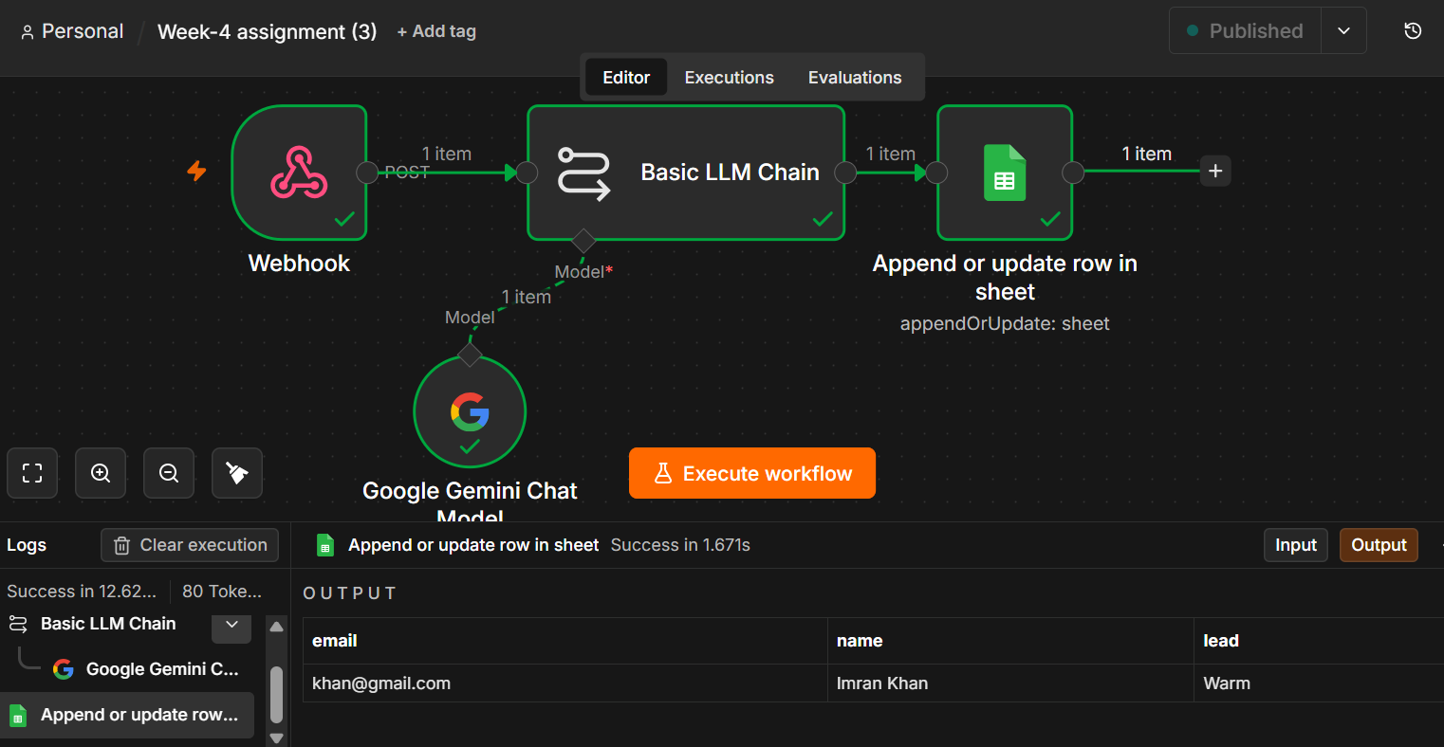

Step 2 ;
Using Postman we send a fake message to the n8n webhook.
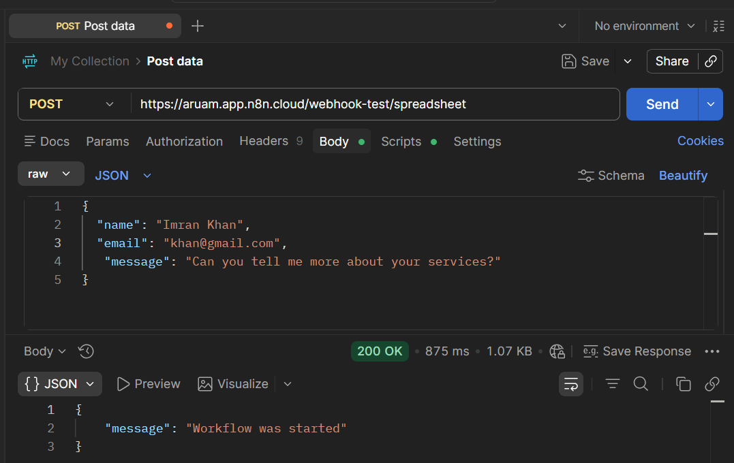
Step 3:
Final result is stored and displayed in google spreadsheets.

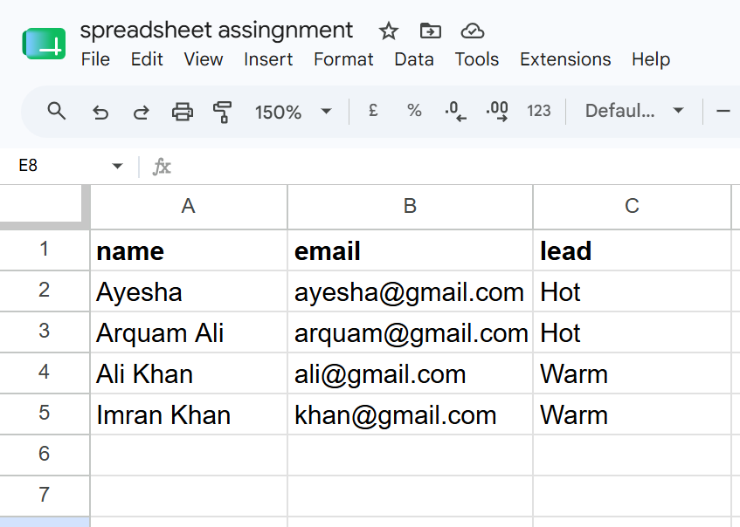

Assignment # 4
Connect it to your CRM. Make that AI decision actually update a real contact or deal in HubSpot or Pipedrive. Show a short recording or screenshots, and explain how it works in your own words.
Step 1:
Now we add hubspot (CRM) to previous workflow and instead to spreadsheet we will create and update contacts in the CRM.
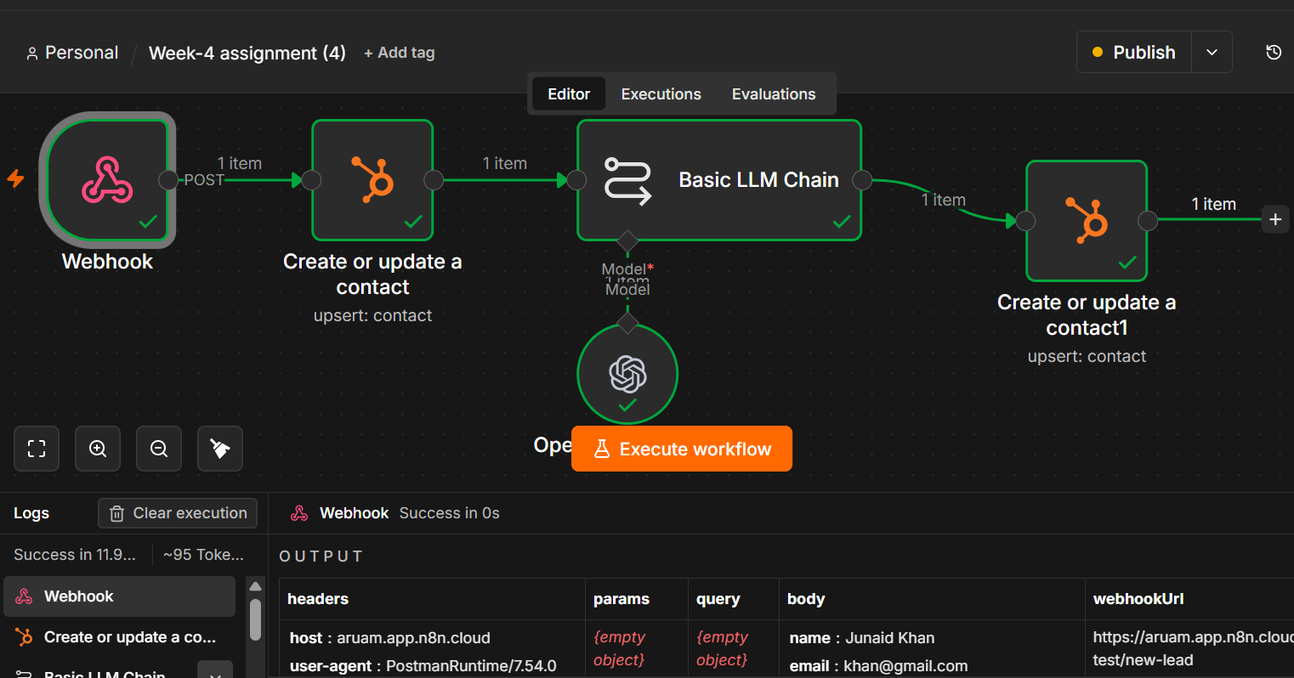
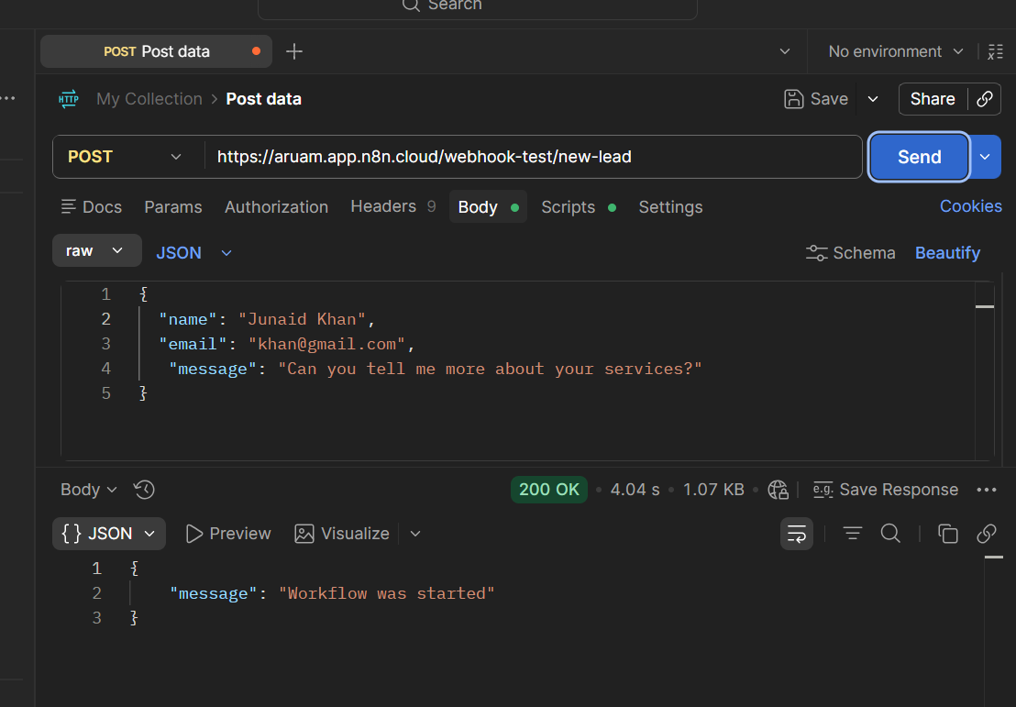
Step 2:
Now after receiving a lead (From Postman) this workflow creates a contact in the hubspot if the Gmail is not found in the contacts then Ai node decides the lead Temperature (hot, warm, cold) and updates the contact’s lead temperature in the hubspot.
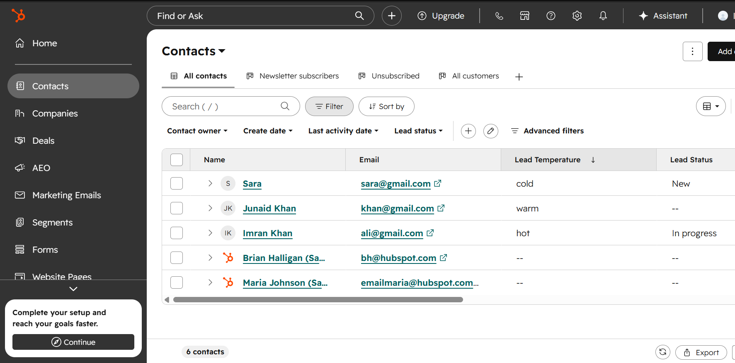

Submitted By:
Arquam Ali Shakeeb
Internship: Invextech
Week: 4

